Q: Are all of these enough to get full marks in the exam?

A: NO. This is a practice sheet. Meaning, you can practice all you want using the questions from this sheet. However, doing well in exams depends upon your ability to understand a question, formulate an answer, and express it correctly. You see, these are humane skills which cannot be guaranteed by completing a practice sheet only. But yeah, Best of luck anyway.

**Chapter 4 (The Processor)**

## **Question - 1:**

**Draw** a diagram of the register file, clearly indicating all input and output pins.

a. Provide a detailed explanation of how the register file performs both read and

write operations.

b. **Explain** why the size of the read/write register pin is 5 bits.

## **Question - 2:**

**Draw** a diagram of the ALU, clearly indicating all input and output pins.

a. **Explain** the significance of the Zero pin in the ALU.

b. **Describe** how the ALU determines which operation to perform on the given

inputs.

## **Question - 3:**

**Draw** a diagram of the ALU Control, clearly indicating all input and output pins.

a. Does the ALU control utilize Instruction bits 30 and 14-12 to generate the output for the LD instruction? Provide a justification for your answer.

b. **Identify** the specific cases in which the ALU control utilizes Instruction bits 30 and 14-12 to generate the output. **Additionally**, explain why only these four bits (Instruction bits 30 and 14-12) are used in such cases.

## **Question - 4:**

**Identify** the necessary resources or components from the list provided to construct the datapath for each of the following instructions.

| PC | Instruction Memory | Data Memory | Register File | ALU | Immediate Generation Unit | Control Unit | ALU Control |
| --- | --- | --- | --- | --- | --- | --- | --- |

| i. | ADD X21, X22, X23 |
| --- | --- |
| ii. | AND X21, X22, X23 |
| iii. | OR X21, X22, X23 |
| iv | ADDi X21, X22, 5 |
| v. | LD X21, 22(X21) |
| vi. | SD X21, 22(X21) |
| vii | BEQ X21, X22, End |

## **Question - 5:**

**Draw** a simplified datapath with control unit that can process ADD X21, X22, X23

## **Question - 6:**

**Draw** a simplified datapath with control unit that can process ADDI X21, X22, 5

## **Question - 7:**

**Draw** a simplified datapath with control unit that can process LD X21, 14(X22)

## **Question - 8:**

**Draw** a simplified datapath with control unit that can process only the following codes:

**LD** X21, 14(X22)

**SD** X22, 16(X21)

Mention the control signals also for each instructions.

## **Question - 9:**

**Draw** a simplified datapath with control unit that can process only the following codes:

**ADDI** X21, X22, 5

**LD** X21, 14(X22)

Mention the control signals also for each instructions.

## **Question - 10:**

**Draw** a simplified datapath with control unit that can process the following codes:

**ADDI** X21, X22, 5

**LD** X21, 14(X22)

Mention the control signals also for each instructions.

## **Question - 11:**

**Modify** the BEQ datapath so that it works for **BNE.**

## **Question - 12:**

**Construct** a single-cycle full-datapath, ensuring that you use only 4:1 multiplexer(s) wherever multiplexer(s) are required.

## **Question - 13:**

Suppose that in a buggy implementation of the RISC V datapath, the AND gate for the branching decision was replaced with an **XNOR** gate. Describe how this error would affect the execution of the following instruction.

i. **SUB** x1, x2, x3 [3 points]

ii. **BEQ** x1, x2, target [3 points]

## **Question - 14:**

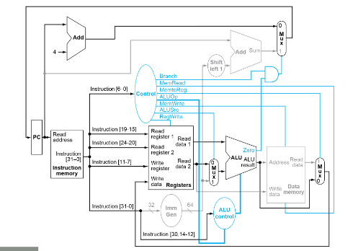

**Determine** the values of the following control bits when executing the instruction "**Add** X21, X22, X23" in the provided single-cycle datapath.

| Branch | MemWrite | RegWrite | ALUSrc |
| --- | --- | --- | --- |
|  |  |  |  |

## **Question - 15:**

**Determine** the values of the following control bits when executing the instruction "**Addi** X21, X22, 12" in provided single-cycle datapath for Q-14

| Branch | MemWrite | RegWrite | ALUSrc |
| --- | --- | --- | --- |
|  |  |  |  |

**Question - 16:**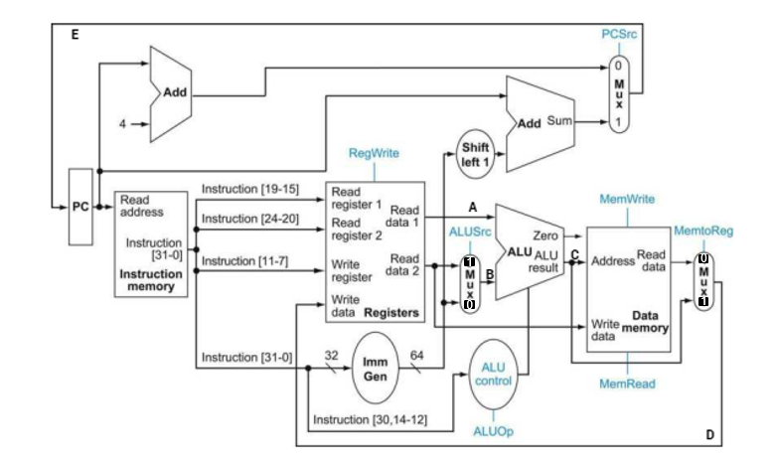

**Determine** the values of the following control bits when executing the instruction "**Add** X21, X22, X23" in the provided single-cycle datapath.

| Branch | ALUSrc | RegWrite | MemToReg |
| --- | --- | --- | --- |
|  |  |  |  |

## **Question - 17:**

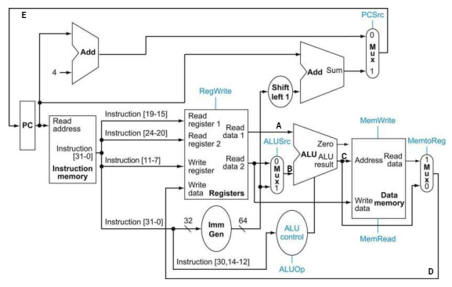

Study the above RISC-V Datapath thoroughly. Assume that initially PC=600h, x1 = 222h, x2 = 444h, x3 = 666h, x4=999h.

**Determine** the values of A, B, C, D, E in hex for the instructions executed **sequentially**. If the value does not matter, write it as X (don’t care)

|  |  | A | B | C | D | E |
| --- | --- | --- | --- | --- | --- | --- |
| i. | sub x1, x2, x1 |  |  |  |  |  |
| ii. | sd x4, 12(x2) |  |  |  |  |  |

## **Question - 18:**

Carefully examine the RISC-V datapath provided in Q-17. Assume the initial values are: PC = 600h, x1 = 222h, x2 = 444h, x3 = 666h, and x4 = 999h. For the following instructions executed **sequentially**, **determine** the hexadecimal values of A, B, C, D, and E. If the value is irrelevant, indicate it as X (don't care).

| i. | sub x1, x2, x1 |  | | | | | |
| --- | --- | --- | --- | --- | --- | --- | --- |
| ii. | sd x4, 12(x2) |
|  |  | PC | A | B | C | D | E |
| iii. | Addi x1, x1, 12 |  |  |  |  |  |  |

## **Question - 19:**

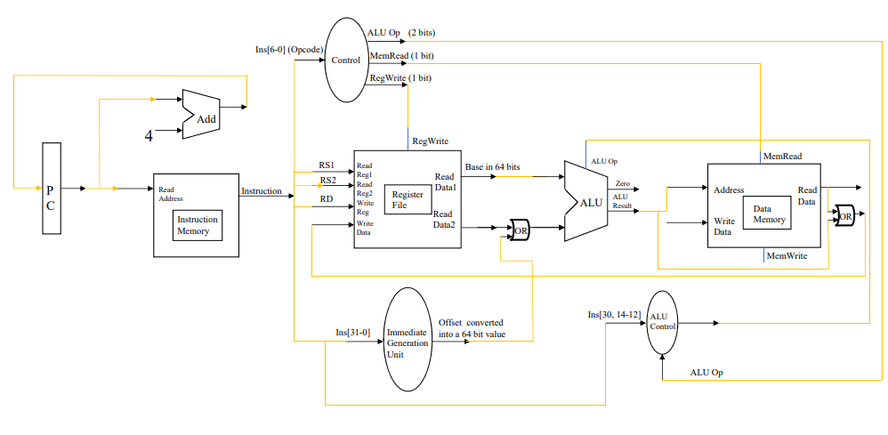Given the following code sequence:

1. ADD X1, X2, X3

2. LD X5, 10(X4)

3. OR X2, X3, X23

Is it possible to execute this code sequence using the provided datapath? If not, correct the datapath.

## **Question - 20:**

PC = 0x0040ABCD123045B1

| **Instruction Memory:**   | Address | Content | | --- | --- | | 0x40ABCD123045AD | 0111 0101 | | ………………………… | 1011 1110 | | ………………………… | 1001 0001 | | ………………………… | 1100 0000 | | ………………………… | 0000 0001 | | ………………………… | 1001 0101 | | ………………………… | 0000 0101 | | ………………………… | 0011 0011 | | **Data Memory:**   | Address | Content | | --- | --- | | 0x40ABCD123045AD | 0111 0101 | | ………………………… | 0111 0100 | | ………………………… | 1000 0000 | | ………………………… | 1000 0001 | | ………………………… | 0000 0000 | | ………………………… | 0001 0111 | | ………………………… | 1000 0101 | | ………………………… | 1111 0011 | |
| --- | --- | --- | --- | --- | --- | --- | --- | --- | --- | --- | --- | --- | --- | --- | --- | --- | --- | --- | --- | --- | --- | --- | --- | --- | --- | --- | --- | --- | --- | --- | --- | --- | --- | --- | --- | --- | --- |

**Fetch** the instruction from memory. **Convert** your answer in Hex.

## **Question - 21:**

The following table shows the different stages involved in executing instructions and the corresponding durations for each stage:

| stages | Instruction  Fetch | Register Read | ALU Op | Memory Access | Register Write |
| --- | --- | --- | --- | --- | --- |
| Duration | 50ps | 10ps | 30ps | 20ps | 10ps |

Given the above durations, determine the total time required to complete each of the following instructions:

|  | Instructions | Time to complete each instructions |
| --- | --- | --- |
| i. | ADD X21, X22, X23 |  |
| ii. | AND X21, X22, X23 |  |
| iii. | OR X21, X22, X23 |  |
| iv | ADDi X21, X22, 18 |  |
| v. | LD X21, 22(X21) |  |
| vi. | SD X21, 22(X21) |  |
| vii | BEQ X21, X22, End |  |

## **Question - 22:**

| Instruction | Time (PS) |
| --- | --- |
| Add X21, X22, X23 | 10 |
| Sub X21, X23, X24 | 20 |
| Mul X22, X23, X26 | 15 |
| LD X22, 0(X21) | 25 |

The above instructions are being run in a **single cycle datapath**.

a. Now determine what is the clock period of this system?

b. What would be the total time to run this instruction sequence?

## **Question - 23 :**

What do you understand by the term "**single-cycle**" in the context of a single-cycle datapath?

## **Question - 24 :**

| Stage | IF | ID | EX | MEM | WB |
| --- | --- | --- | --- | --- | --- |
| Time (PS) | 10 | 20 | 20 | 20 | 10 |

The below instructions are being run in a pipelined datapath. Calculate the time required to execute each instruction.

| Instruction | Time (PS) |
| --- | --- |
| Add X21, X22, X23 |  |
| Sub X21, X23, X24 |  |
| Mul X22, X23, X26 |  |
| LD X22, 0(X21) |  |

Determine what is the clock period of this system?

## **Question - 25 :**

Write a comparison between the single cycle datapath and a pipelined datapath. Mention why pipelined datapath is implemented in real life.

## **Question - 26 :**

In the RISC-V pipelined datapath we have 5 stages. Can we divide these 5 stages into more stages to make the datapath more efficient?

## **Question - 27 :**

Explain Why do data hazards occur in a pipelined Data path?

## **Question - 28 :**

The instructions provided below are executed sequentially within a **pipelined** datapath that is divided into five stages, as depicted in the following diagram. In the diagram, the gray shaded areas represent the periods when tasks are actively being processed in each stage, whereas the unshaded (white) areas indicate inactive portions of each stage.



| Instruction |
| --- |
| Add X21, X22, X23 |
| Sub X21, X21, X24 |
| Mul X22, X21, X26 |
| LD X22, 0(X21) |

Will any data hazards occur during the execution of this instruction set? If so, identify the number of data hazards and clearly circle them.

## **Question - 29 :**

What do you understand about structural hazards? Explain with an example.

## **Question - 30 :**

The instructions provided below are executed sequentially within a **pipelined** datapath that is divided into five stages, as depicted in the following diagram. In the diagram, the gray shaded areas represent the periods when tasks are actively being processed in each stage, whereas the unshaded (white) areas indicate inactive portions of each stage.



| Instruction |
| --- |
| Add X21, X22, X23 |
| Sub X21, X20, X24 |
| LD X22, 0(X22) |

a. Will any data hazards occur during the execution of this instruction set? If so, identify the number of data hazards and clearly circle them.

b. How many clock cycles are necessary to run this instruction set?

## **Question - 31 :**

The following are the time requirements for various stages of a datapath:

1. Instruction Fetch: 25 ps

2. Instruction Decode: 10 ps

3. Register Read: 15 ps

4. Arithmetic or Logical task execution: 20 ps

5. Data Memory Read: 20 ps

6. Data Memory Write: 20 ps

7. Register Write: 25 ps

You are given the following instruction set, executed sequentially:

1. Add X21, X22, X23

2. Sub X21, X23, X24

3. Mul X22, X22, X26

4. LD X22, 0(X20)

Suppose this instruction set is executed sequentially in a single cycle datapath. Answer the following:

a. **Calculate** the **actual** time required to execute each instruction.

b. **Determine** the clock period of this system.

c. **Calculate** the number of clock cycles needed to execute this instruction set.

d. **Determine** the total time required to execute this instruction set.

Now, assume the instruction set is executed sequentially in an ideal pipelined datapath with 5 stages.

Answer the following:

a. **Calculate** the actual time required to execute each instruction.

b. **Determine** the clock period of this system.

c. **Calculate** the number of clock cycles needed to execute this instruction set.

d. **Determine** the total time required to execute this instruction set.